

**BACHELOR OF SCIENCE IN INFROMATION TECHNOLOGY**

**PROGRAMMING PROGECT: BIT 2206**

**SAVINGS AND CREDIT COOPERATIVE MANAGEMENT SYSTEM FOR LOCA SAVINGS AND CREDIT COOPERATIVE**

**BY**

**NJOROGE MORRIS KIMANI**

**16/05387**

**PROGECT SYSTEM DESIGN SPECIFICATION IN PARTIAL FULFILMENT FOR THE REQUIREMENTS FOR THE AWARD OF A DEGREE IN INFORMATION TECHNOLOGY**

**PRESENTED TO: Dr. LUCY MBURU**

# Declaration

I declare that this project is my original work and has not been presented in any other college or university for the award of a Diploma or a Degree.

Student

Name………………………………………………. ……. Date………………………………………….

Signature……………………………………………….

# Table of Contents

Contents

Declaration i

Table of Contents ii

Abstract 1

1.0 Introduction 2

1.1 Purpose 2

1.2 Scope 2

1.3 System Design Constraints 3

1.4 Design Goals and Objectives 3

Objectives 3

1.5 Document Overview 3

2.0 System Architecture 4

2.1 Introduction 4

2.2 Client-Server Model 4

2.3 Design Approach 4

2.4 Architectural Design 4

2.5 Logical Design 5

2.6 Use Case Diagrams 5

2.7 Activity Diagrams 6

2.8 Class Diagrams 7

2.9 Deployment Diagrams 8

3.0 Database Design 9

3.1 Introduction 9

3.2 Normalization 9

3.3 Database Description 11

3.3 Entity Relationship Diagram 12

4.0 User Interface Design 13

4.1 Internal Machine Interfaces 13

4.2 External System Interfaces 13

4.3 Human Interfaces 13

4.4 Interface Design **Error! Bookmark not defined.**

# Abstract

The motivation behind undertaking this project was the inefficiency of the manual system being used by the SACCO which resulted in many errors in the data that was in their possession and also degrading the quality of service they were giving their members.

Therefore, the goal of this project is to automate their manual systems hence eliminating errors that occur during data collection and computations and overall improvement in service delivery to the members of the SACCO.

# 1.0 Introduction

A Software Design Document that provides a description of a software product written by a software designer to give a software development team guidance to the architecture of the software product or how the software is to be built. Within this document is a narrative and graphical documentation in the form of use case models, class diagrams, sequence diagrams, activity diagrams and other supporting information that will prove useful to the development of this project.

This Design Document provides in-depth details for the design of the SACCO Management system for LOCA SACCO.

At this stage (system design) the primary objective is producing a design that will meet the expectations of a high-quality information system which are:

1. Security: It can defend itself against unauthorized personnel trying to access it.
2. Reliable: Always available when needed.
3. Can integrate easily with other systems.
4. Easy to use.
5. Provides timely and useful data.

In this document, emphasis will be laid on four key areas: data, interfaces, architecture and components of the software under production.

## 1.1 Purpose

The purpose of this document is to give insight on the design of the system as candidly as possible to enable development of the software to take off with complete knowledge of what is being built and how.

## 1.2 Scope

This Software Design Document will cover the basic but critical parts of the system hence acting as a proof of concept that it is feasible for largescale use with emphasis being on data collection, manipulating and storage of information. The system will be used in conjunction with existing systems.

This document contains a complete description of the design of the SACCO Management System. Its basic structure is a Client-Server paradigm. Basic forms will be created and coded in Visual Basic.

Staff that will be designated to use the system will be able to make changes to the data that has already been entered into the system.

## 1.3 System Design Constraints

The user requirements’ specifications have directly constrained the system design. This describes the functions that are required by the user which must be implemented as part of the design without leaving out the environmental constraints resulting from the hardware and software environment implementation. These include:

* Integration of data from the current into the new system.
* Implementing an interface between two different applications will be difficult to implement.
* Hardware limitation such as no ownership of a computing device.

## 1.4 Design Goals and Objectives

The goal of the SACCO Management System is to design a system which delivers the functions required by LOCA SACCO to support its business. The importance of software design is:

* Allows proper understanding of the system hence requirements can be met.
* Prevents redundancy and increases reusability.
* Helps to mitigate unknown risks.
* The resulting system will be stable with very lo probabilities of failure.

### Objectives

* **Security:** The system should be able to implement access control methods on who can view which data.
* **Ease of use:** The system should be user –friendly.
* **Flexibility:** The system should enable new requirements of the SACCO to be incorporated without too much complexity.
* **Availability:** The system should always be available for use at any point in time the SACCO needs to utilize it.

## 1.5 Document Overview

The Software Design Document has been divided into sections and subsections which are:

* **Section 2, Architectural Design:** It specifies all the design entities that collaborate to perform all the functions included in the system.
* **Section 3:** contains File and Data Structure Design
* **Section 4:** Contains Normalization whose purpose is to organize data in a way that optimizes logical storage of data.
* **Section 5:** It is the conclusion of the System Design Document. It indicates how the software will be meeting its user requirements.

# 2.0 System Architecture

## 2.1 Introduction

Systems Architecture is a response to the conceptual and practical difficulties of the description and the design of complex systems. It can be viewed as a blueprint of a software system. Here, a software developer analyzes the requirements of the system, determines the components the system will need as well as support the project even after its production is complete.

## 2.2 Client-Server Model

It is a distributed application structure that partitions tasks between providers of a service (server) and service requesters (clients). It is composed of the following:

1. **Servers:** they offer services to subsystems. There are many types of servers, examples include: print servers which avail printing services, database servers which provide access to databases and file servers which offer file management services.
2. **Clients:** They are software that request services from a server.
3. **Network:** It is a connection between two or more computing devices for the purpose of information and resource sharing. It is used by clients to request and obtain services from a server.

Clients access the services provided by a server through remote procedure calls and must be aware of which services a particular server offers. In the case of a server, it must be able to know how many requests it can handle.

## 2.3 Design Approach

To solve a problem, it is easier if the said problem is first broken down into smaller and more manageable proportions to better understand it. This is the best design approach there is in developing software also known as modularization. This is breaking down a complex system into smaller subsystems.

Top-down approach design will be implemented as it describes the overall control architecture of the application before designing the individual modules.

## 2.4 Architectural Design

It’s a concept that focuses on the components of a system and unifies them into a functional fully integrated whole. The proposed system will be developed using a two-tier architectural program. The module of the system being run on workstation will hold the bulk of the system as it will house both the user interface and the application logic while the server will run the database only.

Client

Server

SQL Query/ Retrieval

## 2.5 Logical Design

Its main concern is the processes being performed by the system. It describes what is to be done and how it will be done and is not in any way associated with hardware and software of the system.

## 2.6 Use Case Diagrams

They are at times referred to as behavior diagrams used to describe a set of actions (use cases) that a system (subject) should or can perform in collaboration with one or more external users of the system (actors). There are three main actors in this system namely:

* **Manager:** Holds an administrative role in the system with the full ability to oversee the various users and accounts.
* **Attendant:** This user will be responsible for adding new members into the system and helping them (or already existing ones) to create new accounts.
* **Teller:** This actor will be charged with the responsibility of controlling the accounts of the members. This includes issuing loans, repaying loans and depositing money into the various accounts that are present.
* **Member:**

Below is a use case diagram depicting the attendant, member and teller actors and their roles:

Attendant

Member

Teller

The use case diagram below represents the administrative user and their rolves

<<include>>

<<include>>

<<include>>

Manager

## 2.7 Activity Diagrams

They are basically similar to flowcharts and depict flow from one activity to another which can be described as an operation of the system. The activity could either be sequential, branched or concurrent. Its purpose is to capture the dynamic nature of a system.

Below is an activity diagram of adding a member into the system:

Start

Accept

Deny

Store details in database

Fill Membership Form

End

## 2.8 Class Diagrams

They depict a static state of the system by use of classes, their attributes, methods/operations and relationships between objects.

1

1..*

1…*

1

0…*

1

1

1… *

0…*

1

1..*

1

Loans LoanID Loan_Type LoanReason LoanAmount Load_StartD Load_EndD MemberID TellerID payable paid status new_loan()

Member MemberID Fname Lname IDno Contacts DOB DOE Occupation Residence BeneficiaryName BeneficiarySname BeneficiaryID BeneficiaryContacts

Apply_loan() Make_deposit() Clear_loan()

Accounts AccountID AccountName Account_Value MemberID Date_created Date_Deposited New_Account() New_Deposit()

Attendants AttendantID AttendantFname AttendantLname AttendantPass Contacts Process_membership() create_newAccounts()

Teller TellerID TellerFname TellerLname TellerPass Contacts process_loans () Process_contributions()

## 2.9 Deployment Diagrams

They are used to visualize the topology of the physical components of a computer system where the software components are deployed.

LAN

Object

Database

Server

Object

Client

Workstation

# 3.0 Database Design

## 3.1 Introduction

A database is an organized collection of data stored in a way that minimizes duplication of information and provides consistency of data and access for users. The standard application program interface for many relational databases is Structured Query Language (SQL). These are commands/statements that are used to create databases, insert and modify information into the database, generate reports and even delete a database.

The database for this system will be implemented by use of MySQL 5.6.

**Reasons for choice of MySQL 5.6**

* On-demand scalability
* It is globally recognized as one of the most secure database management systems globally.
* Assurance of 24/7 availability
* Low total cost of ownership due its easy management which saves time during trouble-shooting.
* Meets the needs of demanding applications while providing optimum speed and unique memory caches for enhanced performance.

A good database must have the following qualities:

* **Atomicity:** If one part of a transaction fails, the whole transaction fails and the state of the database remains unchanged.
* **Consistency:** any data entered into the database is valid according to all the defined rules.
* **Isolation:** An incomplete transaction remains invisible to other transactions until it is complete.
* **Durability:** Once a transaction is commited to the database, it will remain so even in the event of a failure or errors in the database.

## 3.2 Normalization

It is a process of decomposing tables to eliminate data redundancy and unwanted characteristics such as insert, update and delete anomalies. There are several steps involved where data is put into tabular form and duplicated data is eliminated form related tables.

The table below show the whole process from the un-normalized for to the third normal form.

|  |  |  |  |
| --- | --- | --- | --- |
| **UNF** | **1st NF** | **2nd NF** | **3RD NF** |
| MemberID | **MemberID (PK)** | **MemberID (PK)** | **MemberID (PK)** |
| ID/Passport_No | **AccountID (PK)** | ID/Passport_No | ID/Passport_No |
| Contacts | **Loan_ID (PK)** | Contacts | Contacts |
| Names | **AttendantID (PK)** | First_Name | First_Name |
| Date_of_Birth | **TellerID (PK)** | Surname | Surname |
| Date_Of_Application | ID/Passport_No | Date_of_Birth | Date_of_Birth |
| Beneficiary_Names | Contacts | Date_Of_Application | Date_Of_Application |
| Beneficiary_Contacts | First_Name | Beneficiary_First_Name | Beneficiary_First_Name |
| AccountID | Surname | Benefiiary_Surname | Benefiiary_Surname |
| Account_Name | Date_of_Birth | Beneficiary_Contacts | Beneficiary_Contacts |
| Account_Value | Date_Of_Application |  |  |
| Loan_ID | Beneficiary_First_Name | **AccountID (PK)** | **AccountID (PK)** |
| Loan_Type | Benefiiary_Surname | Account_Name | Account_Name |
| Loan_Amount | Beneficiary_Contacts | Account_Value | Account_Value |
| LoanReason | Account_Name |  | **MemberID (FK)** |
| Loan_Start_Date | Account_Value | **Loan_ID (PK)** |  |
| Laon_Pay_Date | Loan_Type | Loan_Type | **Loan_ID (PK)** |
| Loan_Status | Loan_Amount | Loan_Amount | Loan_Type |
| Loan_Payable | LoanReason | LoanReason | Loan_Amount |
| Loan_Paid | Loan_Start_Date | Loan_Start_Date | LoanReason |
| AttendantID | Laon_Pay_Date | Laon_Pay_Date | Loan_Start_Date |
| AttendantFname | Loan_Status | Loan_Status | Laon_Pay_Date |
| AttendantLname | Loan_Payable | Loan_Payable | Loan_Status |
| AttendantPass | Loan_Paid | Loan_Paid | Loan_Payable |
| Attendant_Contacts | AttendantFname |  | Loan_Paid |
| TellerID | AttendantLname | **AttendantID (PK)** | **MemberID (FK)** |
| Teller_Fname | AttendantPass | AttendantFname | **TellerID (FK)** |
| Teller_Sname | Attendant_Contacts | AttendantLname |  |
| TellerPass | Teller_Fname | AttendantPass | **AttendantID (PK)** |
| Teller_Contacts | Teller_Sname | Attendant_Contacts | AttendantFname |
|  | TellerPass |  | AttendantLname |
|  | Teller_Contacts | **TellerID (PK)** | AttendantPass |
|  |  | Teller_Fname | Attendant_Contacts |
|  |  | Teller_Sname |  |
|  |  | TellerPass | **TellerID (PK)** |
|  |  | Teller_Contacts | Teller_Fname |
|  |  |  | Teller_Sname |
|  |  |  | TellerPass |
|  |  |  | Teller_Contacts |

## 3.3 Database Description

|  |  |  |  |
| --- | --- | --- | --- |
| **Members Table** | | | |
| **Field Name** | **Data Type** | **Size** | **Remark** |
| MemberID | Integer | 40 | Primary Key |
| Fname | Varchar | 40 |  |
| Lname | Varchar | 40 |  |
| IDno | Varchar | 40 |  |
| Contacts | Varchar | 40 |  |
| DOB | Date |  |  |
| DOE | Date |  |  |
| Occupation | Varchar | 40 |  |
| Residence | Varchar | 40 |  |
| BeneficiaryName | Varchar | 40 |  |
| BeneficiaryName | Varchar | 40 |  |
| BeneficiarySname | Varchar | 40 |  |
| BeneficiaryID | Varchar | 40 |  |
| BeneficiaryContacts | Varchar | 40 |  |

|  |  |  |  |
| --- | --- | --- | --- |
| **Loans Table** | | | |
| **Field Name** | **Data Type** | **Size** | **Remark** |
| LoanID | Int | 40 | Primary Key |
| Loan_Type | Varchar | 40 |  |
| LoanReason | Varchar | 200 |  |
| Loan amount | Double | 10,2 |  |
| Load_Start_Date | Date |  |  |
| Load_End_Date | Date |  |  |
| MemberID | Int | 40 | Foreign Key |
| TellerID | Int | 40 | Foreign Key |
| payable | Decimal | 10,2 |  |
| paid | Decimal | 10,2 |  |
| status | varchar | 40 |  |

|  |  |  |  |
| --- | --- | --- | --- |
| **Accounts Table** | | | |
| **Field Name** | **Data Type** | **Size** | **Remark** |
| AccoutnID | Int | 40 | Primary Key |
| AccountName | varchar | 40 |  |
| Account_VAlue | decimal | 10,2 |  |
| MemberID | Int | 40 | Foreign Key |
| Date_Created | Date |  |  |
| Date_Deposited | Date |  |  |

|  |  |  |  |
| --- | --- | --- | --- |
| **Tellers Table** | | | |
| **Field Name** | **Data Type** | **Size** | **Remark** |
| TellerID | int | 40 | Primary Key |
| TellerFname |  |  |  |
| TellerLname |  |  |  |
| TellerPass |  |  |  |
| Contacts |  |  |  |

|  |  |  |  |
| --- | --- | --- | --- |
| **Attendants Table** | | | |
| **Field Name** | **Data Type** | **Size** | **Remark** |
| AttendantID | int | 40 | Primary Key |
| AttendantFname |  |  |  |
| AttendantLname |  |  |  |
| AttendantPass |  |  |  |
| Contacts |  |  |  |

## 3.3 Entity Relationship Diagram

Create

Deposit

Register

Accounts AccountID AccountName Account_Value MemberID Date_created Date_Deposited

Loans LoanID Loan_Type LoanReason LoanAmount Load_StartD Load_EndD MemberID TellerID payable paid status

Apply for

Process

Attendants AttendantID AttendantFname AttendantLname AttendantPass Contacts

Member MemberID Fname Lname IDno Contacts DOB DOE Occupation Residence BeneficiaryName BeneficiarySname BeneficiaryID BeneficiaryContacts

Attendants AttendantID AttendantFname AttendantLname AttendantPass Contacts

# 4.0 User Interface Design

## 4.1 Internal Machine Interfaces

A client-server network will first need to be created before the system is installed in both the client and server. The database will be installed in the server and the user interface in the client machines. Records added or updated by the user will automatically reflect on server.

## 4.2 External System Interfaces

Resources such as printers will be available on the network while computer accessories such as a keyboard and mouse will only be usable on one computer only. The server and workstations should have antivirus installed to protect them against malware, viruses and other malicious software that will threaten their operations. The antivirus should be frequently updated online hence internet access will be necessary.

## 4.3 Human Interfaces

All the workstations will allow the users to interact with the system after they have been authenticated to do so. The server however will not be accessible to them. This is because it will have a command-line interface which only an expert will be able to handle. It will also minimize the possibility of unknown errors from occurring.

## 4.4 Interface Design

This depicts how users will be able to interact with the system to perform the actions they require. They will do so via forms made using Visual Basic.

### 4.4.1 Description of the user interface

* **Command buttons:** They will issue commands to the system such as: open, save, edit, delete, search etc.
* **Command line:** The user can write SQL statements to query the database.
* **Pop-ups:** They will serve as error messages telling the user what error is occurring and why.

### 4.4.2 Description of the user interface

Screen images depict what the user will see when performing certain tasks in the system. Below are some of those designs that will be used in the system.

#### 4.4.2.1 Login Form

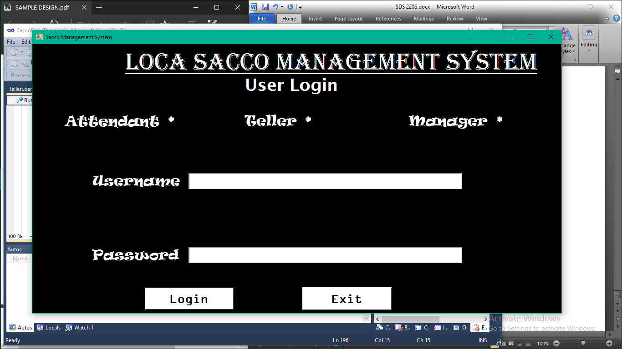

#### 4.4.2.2 Add New Member Form

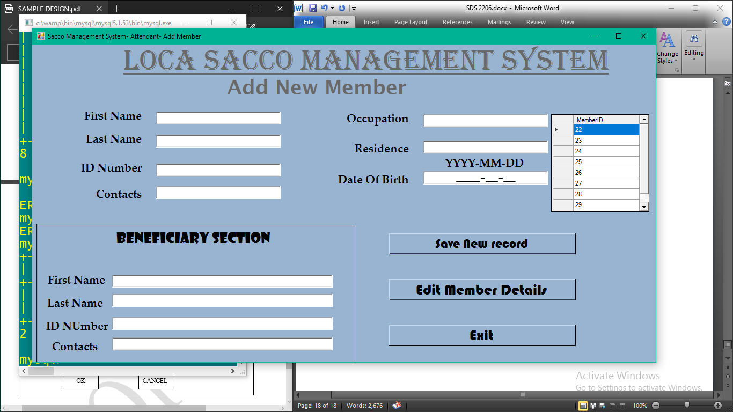

#### 4.4.2.3 Add New/Remove Member Account Form

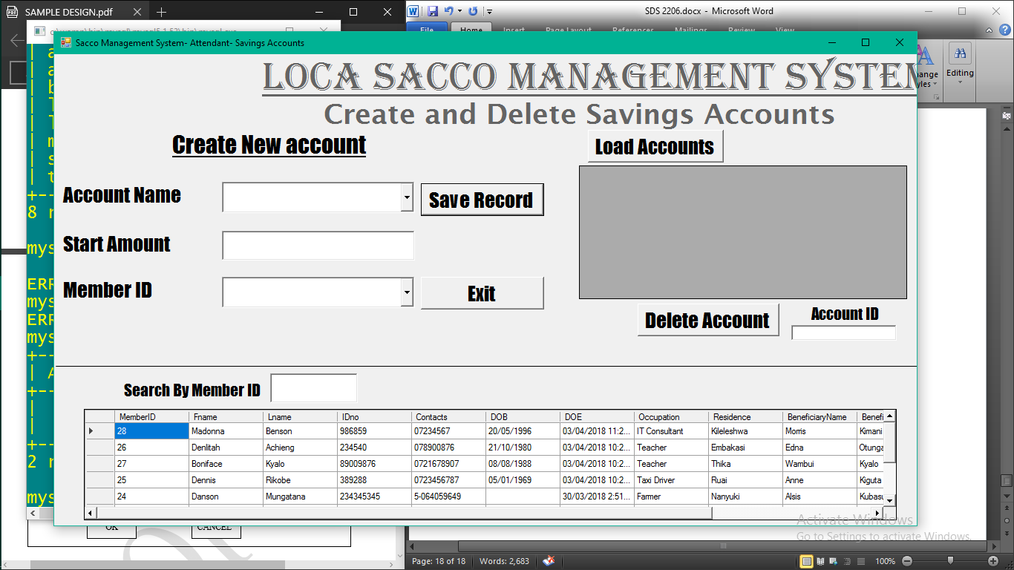

#### 4.4.2.3 Loans Form

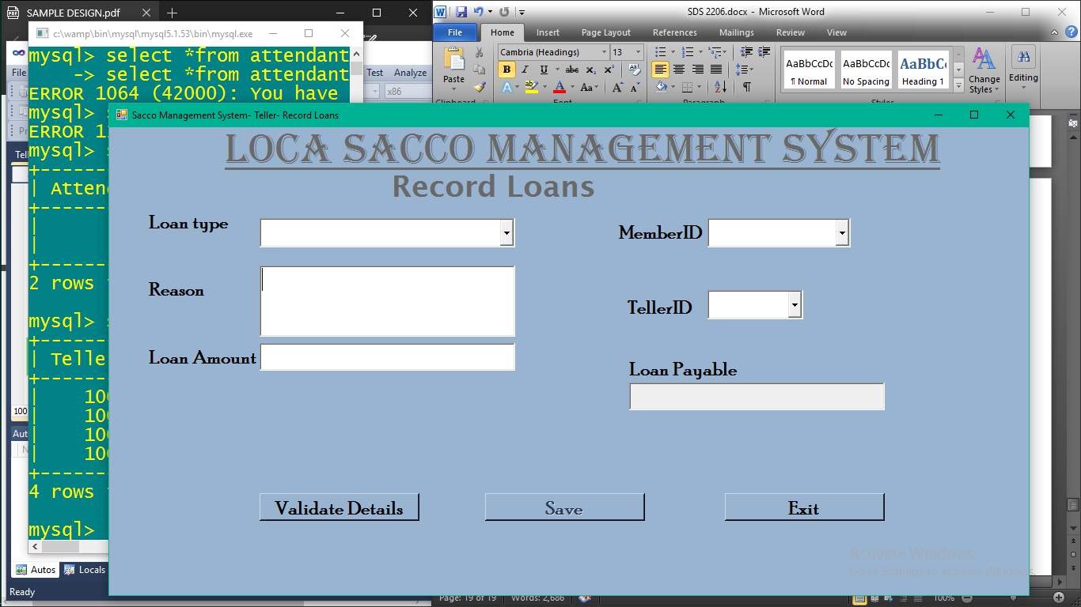

#### 4.4.2.4 Teller’s Main Menu Form

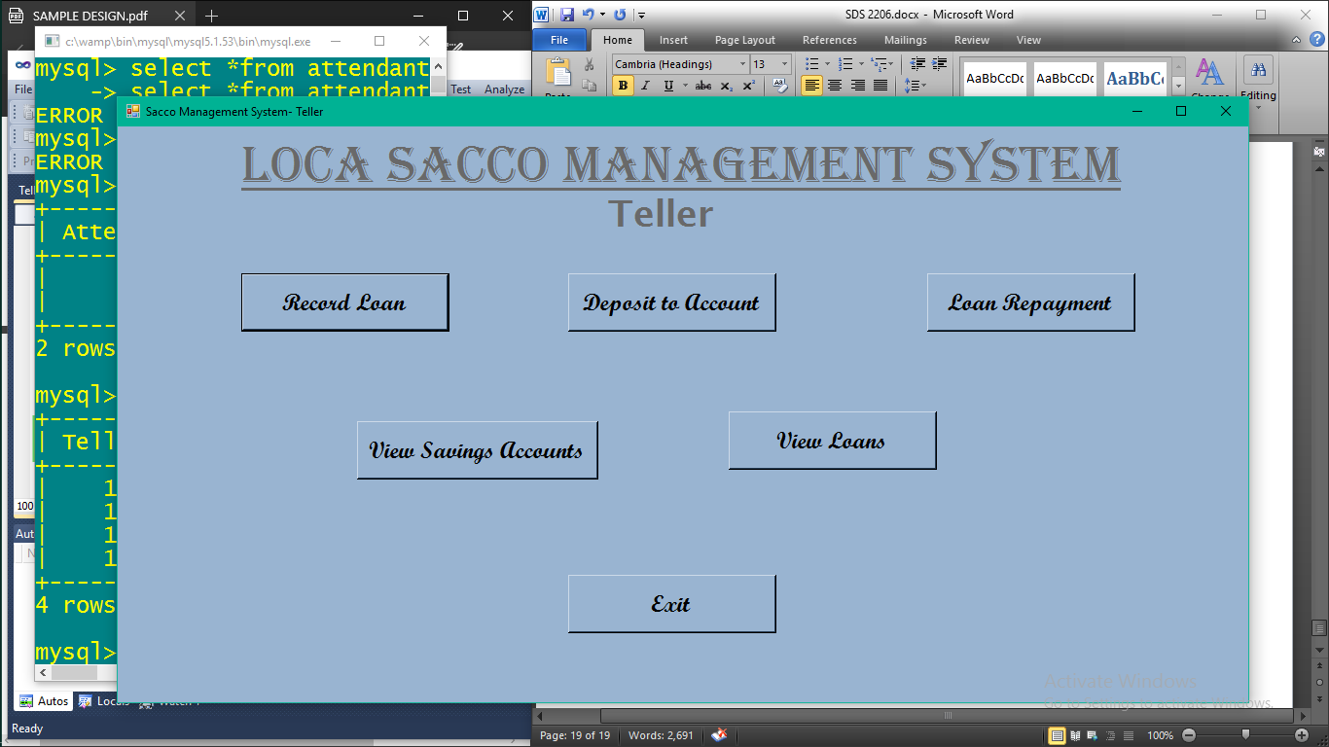

### 4.4.3 Components Available

* **Save Button:** Used to save records.
* **Search button/textbox:** Searches for a specified record from within the database.
* **Validate button:** Used to cross-check data entered with that in the database.
* **Load table button:** Populates tables with data from the database.
* **Delete Button:** Removes unwanted information from the database.
* **Update Button:** Saves a record that has been successfully edited.
* **Exit button:** Closes down a form and automatically opens the previous form or closes down the interface completely. Hence restart is required.

### 4.4.4 Software Context

The system will include three main modules: the Teller, Attendant and Manager module. Each module will have specified functionality with each being different from the other or sharing some degree of similarity in some sub-modules.

### 4.4.5 Expected Software Response

The system is expected to run smoothly without any fatal errors that may cause its operation to halt completely or crash. This is because the system has undergone vigorous testing by the system designer and will be handed to qualified team of testers. But in case of any unexpected errors during testing, they will be corrected before implementation by the client.

### 4.4.6 Packaging and installation

The system on completion will be packaged neatly into a compact disc and copyrighted. It will be accompanied by its documentation.

## 5.0 Conclusion

The system will be able to fulfil the described user requirements and tests plan documents will be designed to help verify this argument.

## 6.0 References

1. Frank B. Watts (2004) Engineering documentation control handbook
2. En.tekstenuitleg.net/articles/software/database-design-tutorial.html
3. [www.tutorialspoint.com](http://www.tutorialspoint.com)
4. Alan Dennis, Barbara Harley Wixom, Ronerta Marie, Roth Hardcover (2012) Systems Analysis and Design 5th Edition